**LAMP**

1. Install Apache :-

# yum install httpd

# service httpd start

Allow Apache server default port 80 through your firewall/router if you want to connect from remote systems. To do that, edit file /etc/sysconfig/iptables,

# vi /etc/sysconfig/iptables

Check Port no. 80 open or Not . if not Add the following lines.

[...]

-A INPUT -m state --state NEW -m tcp -p tcp --dport 80 -j ACCEP

[...]

Restart iptables:

# service iptables save

# service iptables restart

Now open the browser using **http://ip-address/**

1. Install Mysql :-

# yum install mysql

# yum install mysql-server

# service mysqld start

# chkconfig mysqld on

Once it is done installing, you can set a root MySQL password:

# mysql_secure_installation

1. Install php :-

# yum install php

# yum install php-mysql

Although LAMP is installed on your virtual server, we can still take a look and see the components online by creating a quick php info page

To set this up, first create a new file:

#vim /var/www/html/testphp.php

Add in the following line:

<?php

phpinfo();

?>

Then Save and Exit.

Restart apache so that all of the changes take effect on your virtual server:

# service httpd restart

Now open the phptest.php file in your browser using http://ip-address/testphp.php or http://domain-name/testphp.php. Scroll down and you will see the mysql module will be presented there.

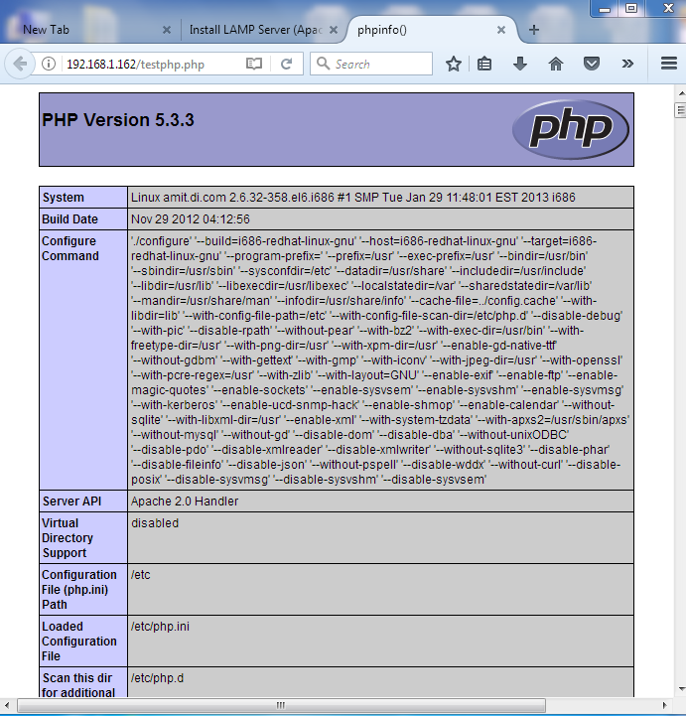

1. Installing PhpMyAdmin :-

Type following coomand to Download phpmyadmin rpm Package

# yum install php*

# wget http://www.tejasbarot.com/RPMs/phpmyadmin-install-tejas-barot-2.0-2.noarch.rpm

# rpm -ivh phpmyadmin-install-tejas-barot-2.0-2.noarch.rpm

# yum install phpmyadmin –nogpgcheck

# yum repolist

# yum install phpmyadmin

Edit the phpmyadmin.conf file.

# vim /etc/httpd/conf.d/phpMyAdmin.conf

In that replace all 127.0.0.1 address to your Ip-Address

[...]

Alias /phpMyAdmin /usr/share/phpMyAdmin

Alias /phpmyadmin /usr/share/phpMyAdmin

#<Directory /usr/share/phpMyAdmin/>

# <IfModule mod_authz_core.c>

# # Apache 2.4

# Require local

# </IfModule>

# <IfModule !mod_authz_core.c>

# # Apache 2.2

# Order Deny,Allow

# Deny from All

# Allow from **192.168.1.162**

# Allow from ::1

# </IfModule>

#</Directory>

[...]

# service httpd restart

Now you can access the phpmyadmin console by navigating to http://server-ip-address/phpmyadmin/ from your browser.

Enter your MySQL username and password which you have given in previous steps. In my case its “root” and “dada123”.